Data visualisation: composition and diversity
Main findings to highlight:
- Methanotrophs (MOB) detected in wood, bark, and soil, but highest in wood.
- MOB abundance in wood:
  - Up to 5.2% in B. pubescens
  - Up to 3.2% in A. glutinosa
- Bark and soil generally had <1% MOB by 16S.
- Alphaproteobacteria (especially Methylobacterium) were dominant MOB.
- Betaproteobacteria present in wood (1.5–1.7%) but rare elsewhere.
- Gammaproteobacteria MOB were scarce overall.
- Key genera across tissues: Methylibium, Methylobacterium, Methylosinus, Methylocella.
- The comparison with shotgun metagenomics would be essential as it detected more genera of methanotrophs (similar abundance) and methanogens.
Relationships between methanotrophs/methanogens and tree variables:
- MOB abundance not driven purely by pH or moisture but peaked at pH ~5.
- In B. pubescens:
  - MOB correlated with MOP-HA and weakly with MOP-LA.
- In A. glutinosa:
  - Strong MOB correlations when MOP-LA and MOP-HA considered together.
- Across species:
  - MOB + moisture together strongly predicted MOP-LA, MOP-HA, and stem
Composition:
Bacterial CLASSES and methanotrophic FAMILIES and GENERA
- Stacked Bar Plots: Visualize the relative abundance of the major taxonomic groups for each of the 12 samples. Group the bars by compartment to clearly illustrate compositional differences between the soil, bark, and wood.
- Heatmap: Create a correlation matrix linking key variables:
  - Relative abundances of methanotrophs - presence/absence
  - CH₄ flux and production/oxidation potentials
  - Environmental groups (Compartment, Species)
This visualization effectively shows which taxa are significantly correlated (r) with the measured methane activity.

- Abundance vs. potential scatter plot: Plot the relative abundance of the methanotrophs (from 16S data) against the measured CH₄ oxidation potential to demonstrate the functional relationship.

From Arnold 2024:
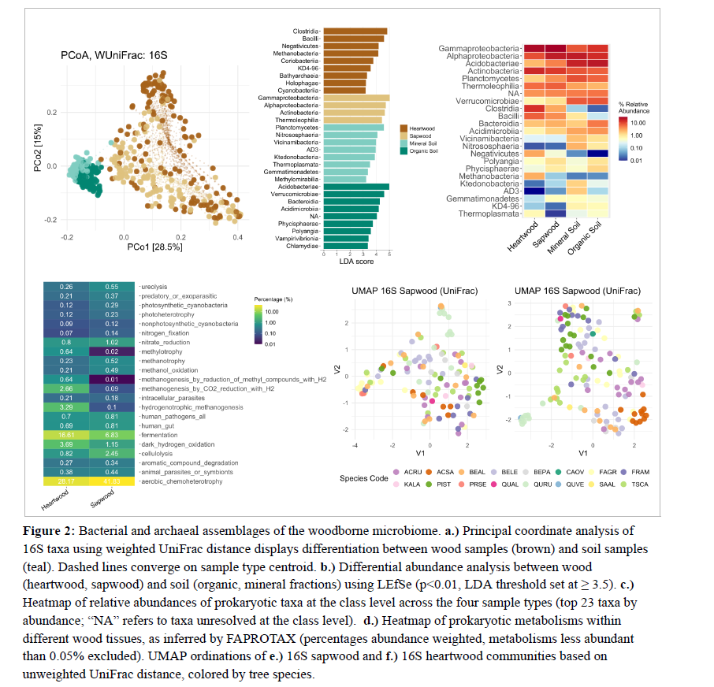

Diversity
Bioinformatics pipelines, such as QIIME, mothur, and DADA2, process sequencing data to calculate diversity indexes, which are typically classified into alpha and beta diversity metrics.
- Alpha Diversity: Alpha diversity measures the microbial diversity within a single sample. Key metrics include those focused on richness and combined diversity:
- Richness (Observed OTUs/ASVs): The total count of distinct taxonomic entities found in the sample.
- Chao1: A non-parametric estimator used to estimate the total number of species present, including those at low abundance.
- Shannon Index: A common measure combining species richness and the evenness of their distribution.
- Inverse Simpson Index: Measures diversity but places greater emphasis on the abundance of the most common species.
- Beta Diversity: quantifies the compositional differences or dissimilarity between microbial communities across multiple samples or groups. These differences are often visualized using ordination plots like Principal Coordinate Analysis (PCoA).
- Bray-Curtis Dissimilarity: A widely used measure that quantifies compositional differences based on abundance, giving more weight to common species.
- UniFrac Distance: Measures differences based on phylogenetic distance. The Weighted UniFrac distance incorporates species abundance, making it less sensitive to rare taxa.

Visualisation of community diversity – whole bacteria/16S
- Box Plots: Display the distribution of diversity indices (e.g., Shannon index (H') and observed richness) across the three compartments (Soil, Bark, Wood) to statistically compare niche variability.
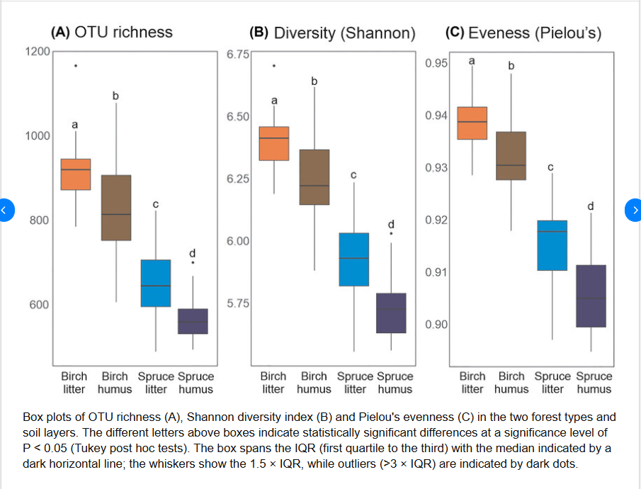
Example:

- Ordination Plots (PCoA or NMDS): Use Principal coordinates analysis (PCoA) or Non-metric multidimensional scaling (NMDS) based on a Bray-Curtis dissimilarity matrix derived from 16S relative abundances. Plot the 12 samples, coloring the points by Compartment (Soil, Wood, Bark) and using different shapes for Tree Species to visualize whether microbial communities cluster primarily by location or host.

Example from Arnold 2024:

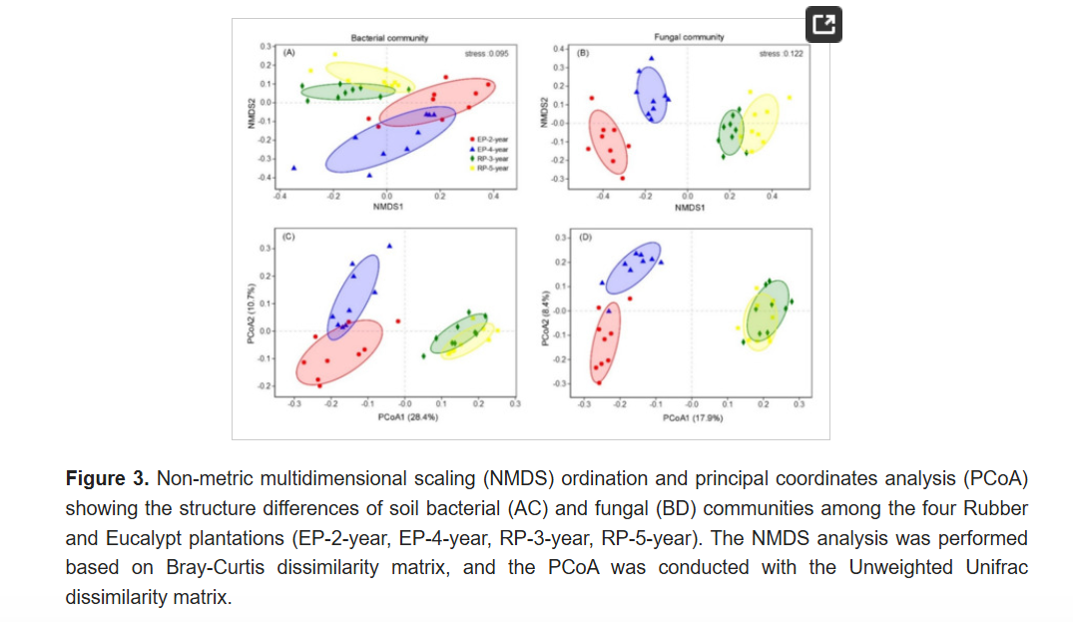
Another example:

